**New Database Configuration-Elastic Pool and Backup (Self - Signed)**

**Version 1.0**

|  |  |  |  |
| --- | --- | --- | --- |
|  | **Prepared/ Updated By** | **Reviewed by** | **Approved By** |
| **Name** | Anubhav Krishna |  |  |
| **Role** | Programmer Analyst |  |  |
| **Signature** | *Anubhav Krishna* |  |  |
| **Date** | 19-Sept-2021 |  |  |

# **Creation of New Azure SQL Database**

For a new database to be created in Azure there can be multiple scenarios and based on the request we need to decide.

# **Copy from existing production to non-production/non-production to production**

**Step1**: Create a copy of the production/non-prod database and choose LRS as backup redundancy option

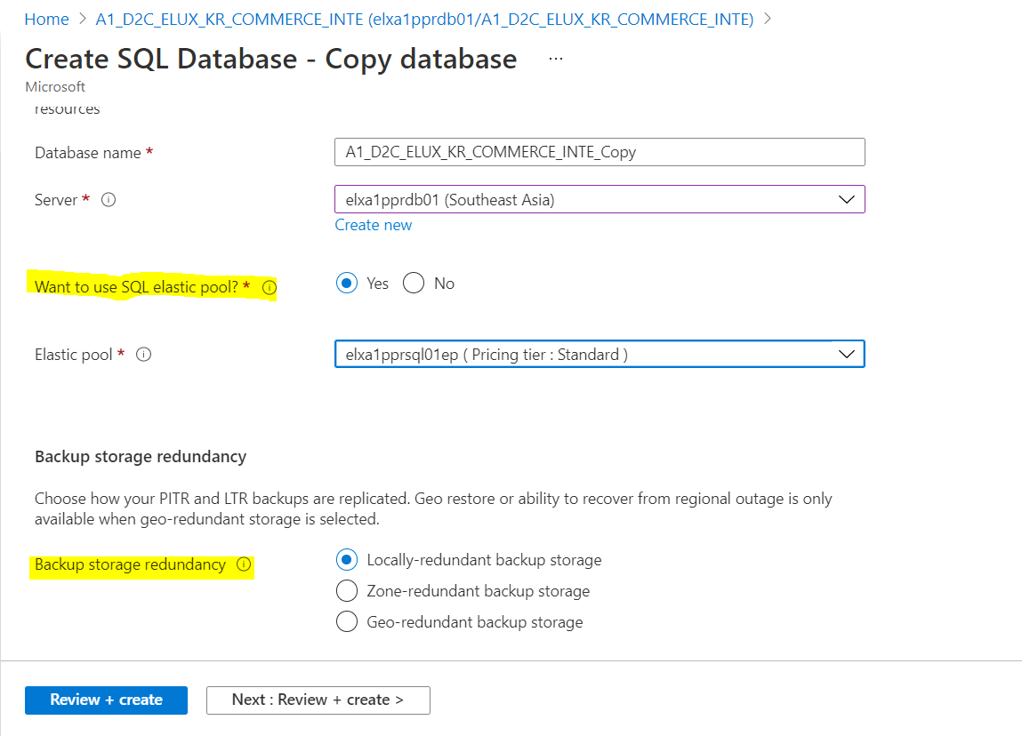

**Step 2**: Export the copied database to storage account aoteampprstorage in a container with name of the ticket.

Select the location of the .bacpac file, choose SQL server as Authentication type and enter the credentials

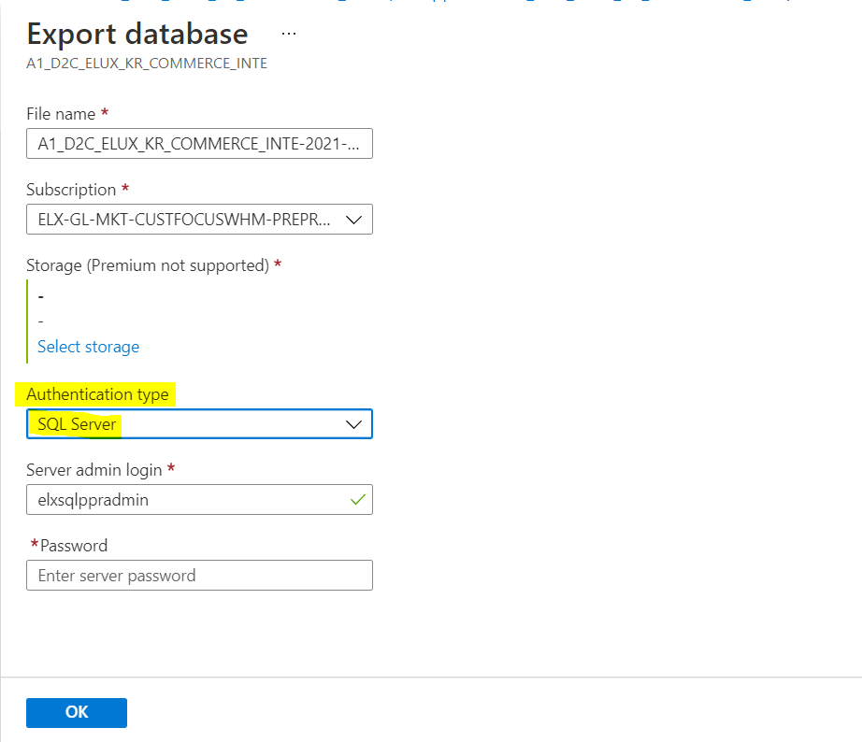

**Step 3**: To create the new database, select the destination database server and import the .backpac file, created in step 2.

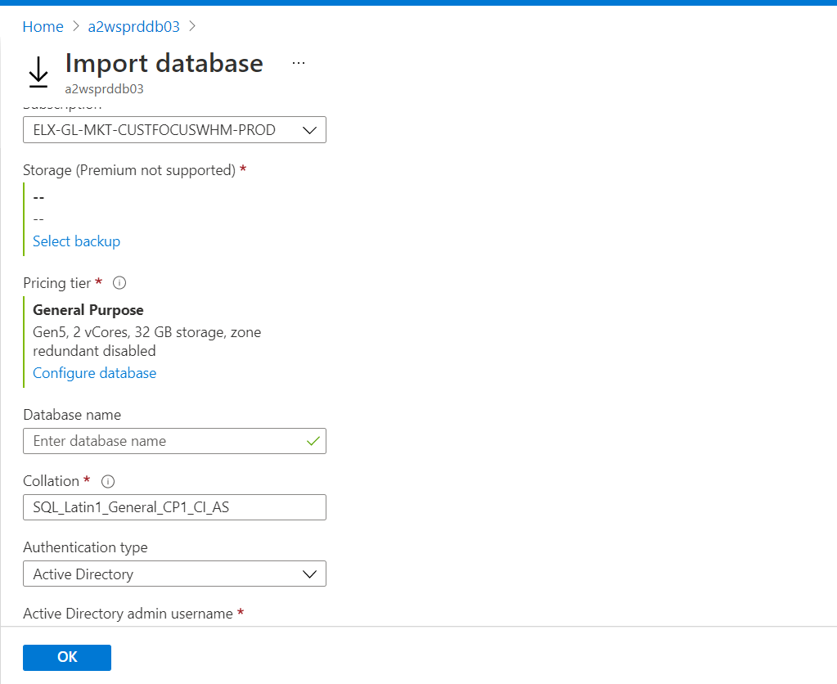

Under the pricing tier section Click on configure the database and select the pricing tier as shown below

Service tier- Standard

DTU (10 to 50 depending upon the .bacpac file size).

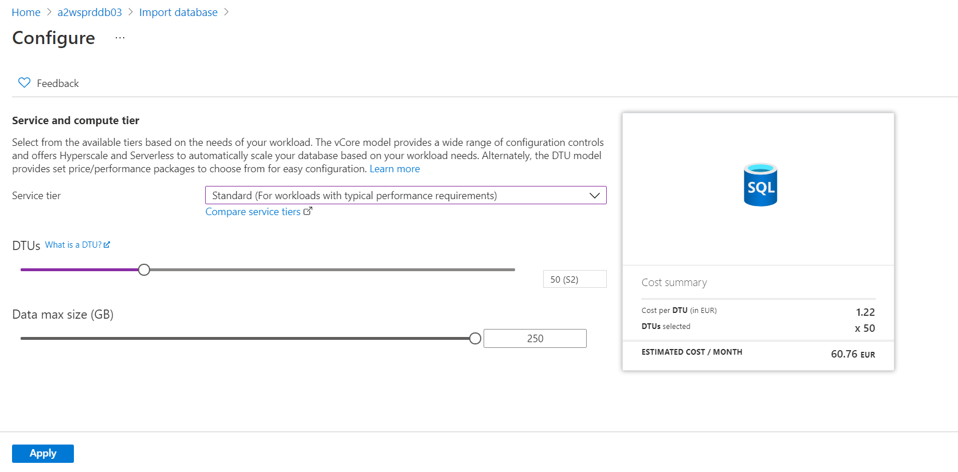

**Step 4**: After import request submitted successfully, we can check the status under the import/export history available at left pane of the database server.

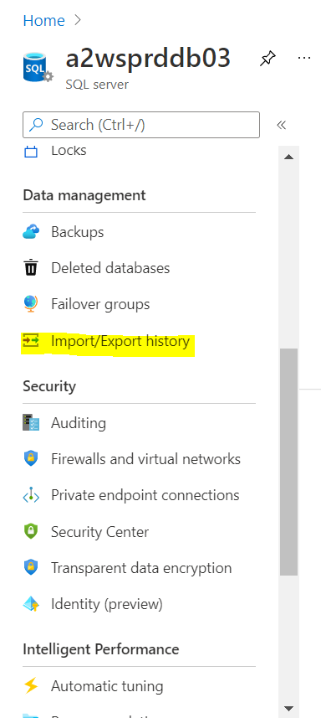

**Step 5**: Once import request completed successfully, add the database to the respective Elastic Pool.

Select the elastic pool based on the region, go to configure section and click on Add database section to add the newly created database as shown below

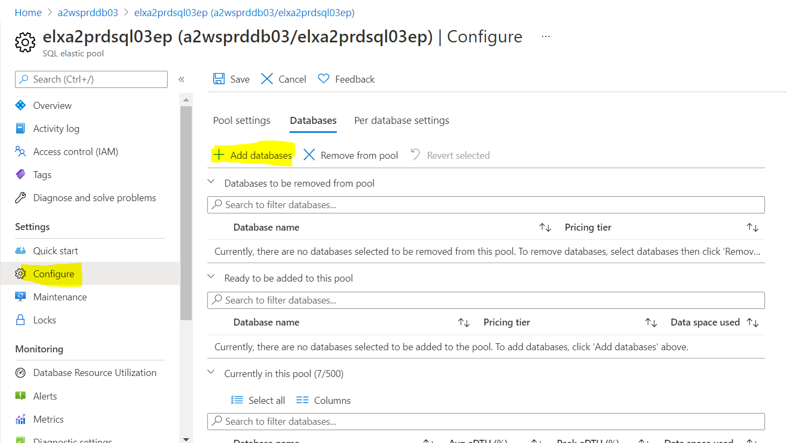

# **Copy from existing production to production/non-production to non-production**

If the request is to create a new database in the same database server, export/import process is not required.

Create copy of the source database and rename the copied database with destination database name.

Configure the backup of the new database as per the document in next page.

# **Configure backup/retention period of Azure SQL database**

After database created successfully, we need to configure the backup of the newly created database as per below backup Policy.

**Production Database: 35 days**

**Non-production Database: 7 days**

* Select the database server under which the new database is created and under Data Management section click on Backup as shown below

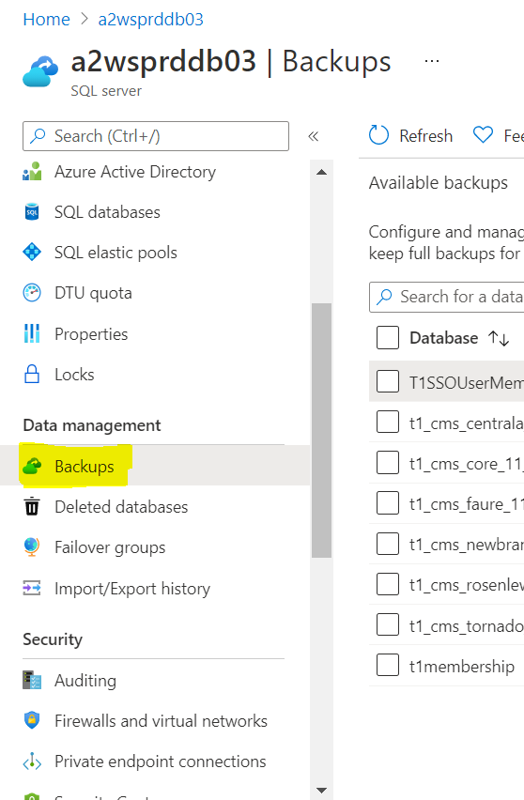

* Under the Backups select the required database and Click on configure policies, under point-in-time-restore select the PITR backups days

